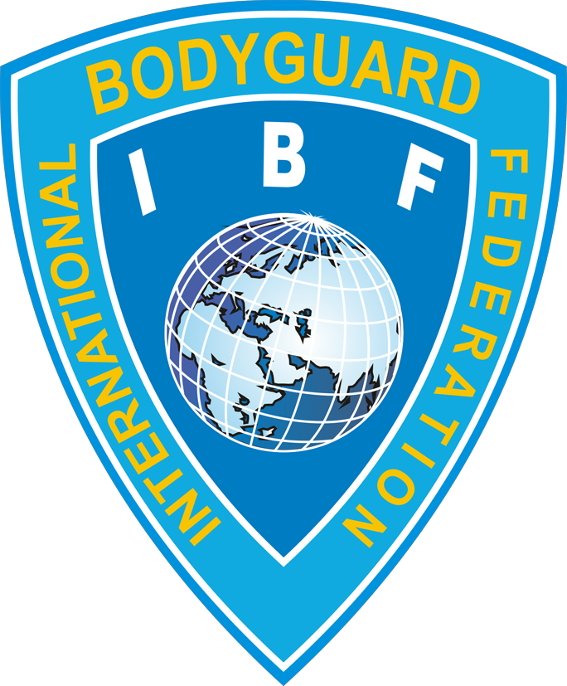
International Bodyguard Federation
Международная федерация телохранителей
Ukraine, 04308, Kyiv, Pravdy prospect, 33, «А», reg. № 36472559,
email: vsgo-fou@i.ua, tel.(38044) 255-07-00, (38067) 401-01-16

Украина, 04308, г. Киев, пр-т Правды, д. 33, литера «А»,
код ЕДРПОУ 36472559, р/с 26005010045574 в АО «Укрексимбанк», МФО 322313,
email: vsgo-fou@i.ua, тел.(044) 255-07-00, (067) 401-01-16
«25» 07 2016 № 8/318

Dear colleagues and friends!

As a Head of the Organizing Committee, I'm glad to invite you to take part in the VII World Bodyguard’s Cup.
The Championship arranged by the Department of State Guard of Ukraine will take place on 17-20 of September, 2016 in Kyiv, Ukraine.

Since 1998 in this tournament have participated teams from Armenia, Australia, Byelorussia, Bulgaria, Denmark, Georgia, Hungary, India, Italy, Kazakhstan, Kyrgyzstan, Latvia, Macedonia, Moldova, Romania, South Korea, Ukraine, United States of America.
This Championship will upgrade the level of bodyguard professional skills and will help to acquire practical knowledge and to exchange experience in this field.
After the end of the tournament it's foreseeing to conduct the round table on "Organization and Support of Security and Antiterrorism Events in the Modern World".
Your participation in this Championship will promote fortification of interaction between the law enforcement organizations in fighting against criminals and will encourage the development of special protection events.
If you are interested in participation in this Championship please send us an application on the following:

E-mail: vsgo-fou@i.ua
Site: www.fou.kiev.ua
The representative of the Organizing Committee
Leonid Kucheriavyi

Tel/fax + 38 044 255 07 00
+ 38 067 401 01 16

Sincerely,


Secretary General of the Federation L.Kucheryavy

