
International Bodyguard Federation
Международная федерация телохранителей
Ukraine, 04308, Kyiv, Pravdy prospect, 33, «А», reg. № 36472559,
email: vsgo-fou@i.ua, tel.(38044) 255-07-00, (38067) 401-01-16

Украина, 04308, г. Киев, пр-т Правды, д. 33, литера «А»,
код ЕДРПОУ 36472559, р/с 26005010045574 в АО «Укрексимбанк», МФО 322313,
email: vsgo-fou@i.ua, тел.(044) 255-07-00, (067) 401-01-16
«02» 04 2021 № 8/208

XI BODYGUARD WORLD CUP
STATUTE

Cherkassy 2021

1. Goals
The World Cup is aimed at:
- popularization and development of service and applied sport;
- improvement of bodyguard training level.

2. Schedule and place of competitions
(16 – 20 July 2021, Cherkassy, Ukraine)
- July 16 – teams’ arrival and accommodation;
- July 16, 6 p.m. – meeting of representatives and main referees;
- July 17-19 – competitions;
- July 20 – departure.

3. Organization and order of conduct
The general organization and conduct of the competition is carried out by the organizing committee, which includes representatives of the International Bodyguard Federation, the Department of State Guard of Ukraine, Bodyguard Federation of Ukraine. Main referees are responsible for the direct contest conduct.

4. Competitors (Teams)
Participants of the competition are :
- State Security Services, Guarding and Law Enforcement Agency teams of foreign countries;
- prize-winner teams of Ukrainian Bodyguard World Cup.
Team Members: 5 persons ( 4 Competitors + 1 Representative).
The team may include spare members included in the application.
In case a participant is unable to continue the competition due to the injury, a substitute participant or team representative may replace him.
Permission to replace the main competitor is given by the chief referee of the competition on the basis of a statement from the team representative and the competition doctor’s findings.

5. Agenda of competitions
Day 1: - rendering the first-aid to VIP and executing his evacuation;
- demonstration of tactics and technology of VIP foot-escorting and physical protection skills demonstration;
- hand-to-hand combat.
Day 2: - overcoming an obstacle course on a car;
- improvised explosive devices search;
Day 3: - combat shooting during protective escort;
- high-speed combat shooting from various positions;
- shooting from the car.
The order of the program parts may vary.
The specifications for doing all-round parts are attached.

6. Equipment and ammunition
Each team should have ammunition and equipment for competitions.
The Championship Organizers provide weapon for the competitions.
Personal weapon is also allowed, provided that information on the weapon (type and serial number) is given in advance in written.
Cars for competitions will also be provided. Teams may use their own 4 or 5-door vehicles with the engine capacity of up to 3 000 cm³.

7. Application
Preliminary information on participation in the competition is sent in writing, by e-mail or fax until June 20, 2021, and applications for participation in the competition are submitted to July 01, 2021 at:
International Bodyguard Federation, Kyiv
е-mail: vsgo-fou@i.ua
Representative of Organizing Committee:
Leonid Kucheriavyi
tel/fax +38044 255-07-00;
+38 044 281-26-66
mobile +38 067 401-01-16
The credentials committee serves:
- nominal application for all team members in the prescribed form, which indicates: surname, first name and patronymic, date, month and year of birth, sports category, region, membership in a sports organization or club, coach's name, identification code. Applications are certified by the relevant medical institution or sports clinic (date, signature and seal must be opposite each participant), and also approved by the head of the unit;
- passport, insurance policy;
- a certificate or report (for military personnel) that the participant is aware of the weapon structure, the rules and security measures when handling it.

8. Financing conditions
Funding for competitions is provided by the International Bodyguard Federation and teams participating in competitions.
The team member contribution per day is:
Cost for one person per room/day with full meals is € 35-40.
The fee for each additional member of the delegation (reserve member, massage therapist, member of the support group, etc.) is € 50.
Transfer and travel related expenses to/from Kyiv are covered by the teams.

9. Winners Determination
Team places are determined by the smallest amount of places received by the team and test participants in all types of all-around. In case of the same amount of places, the advantage is given to the team, which has a greater number of first, second and next places.
Team winners and prize-winners of competitions are awarded with cups, medals, diplomas and memorable gifts.

The Statute is an official invitation to the competition!

Specifications for all-round exercises

Part#l: Tactics and technique of escort with physical protection techniques
Specifications and order of performance
Participants: 4 persons (one as VIP) from each team.
Two automobiles stay not far from an entrance of a building. There are one bodyguard with VIP in one of the automobiles and other two bodyguards in another one.
After the bodyguards getting out of the cars they place around the VIP, start moving in the given direction. There are two groups of people (10-15 persons in each one) by both sides of the VIP's way.
During the passage of the route, one of the assistants (from the group or the mock-ups of the building fragments), on referee’s command imitates an attack with a stick, blows of hands, feet, a knife or other improvised objects. One of the bodyguards repels the attack, demonstrating a physical protection technique, while the other two provide cover and evacuation of the VIP to a safe place or car.
The mode of estimation:
1. getting out of the automobile - up to 10 points
a) location around the car and monitoring the situation in a radius of 360 ° - up to 3 points;
b) cover at the time of exit, the position of the door after exit - up to 4 points;
c) line-up around VIP before the start of the movement - up to 3 points.
2. VIP escort from a car to a group of assistants imitating a crowd - up to 10 points:
a) response to the threat by rearranging - up to 3 points;
b) control of the situation in a radius of 360 ° - up to 3 points;
c) the actions of the bodyguard on the attempt of individual citizens to approach the VIP in order to hand flowers, pass a package, greet a hand, take a picture, etc. - up to 4 points.
3. Demonstration by the bodyguard a physical protection technique in repelling an attack on a VIP during movement - up to 30 points.
4. Cover and evacuation after an attack - up to 10 points
a) giving a voice signal indicating the type and direction of the attack - up to 3 points;
b) cover and evacuation of a VIP to a shelter in the direction opposite to the attack - up to 7 points.
The winner of this competition part is determined with the greatest sum of points scored by the team.

Part #2: Hand-to-hand fighting
Specifications and order of performance
Participants: 2 persons (all other participants' assist).
Hand-to-hand combat is carried out in the form of a demonstration of protective actions against strikes with a knife, foot and short stick. The list of attacking actions is determined by cards and consists of three questions.
The performer and 3 assistants occupy the initial position: the participant who performs the techniques takes a position in the center of the site, and the assistants - at a distance of 1.5-2 meters around him. The referee acquaints the assistants with the contents of the card and determines the sequence of the attacking actions.
The first technique is carried out on referee’s command, the second and third - after the performer has accepted the initial position, facing the assistant. Protective actions must be carried out sequentially one by one and end with a painful hold or throw with a final hit.
The bodyguards will demonstrate such techniques:
- protection against hits with knife, foot, short stick;
The commission of 5 referees estimate an execution of each hold with a scale of 10 points (except highest and lowest points).
Places are determined by the highest amount of points scored by team members.

Part #3: Combat Shooting during Protective Escort Competition
(application №1)
Target: a zone figure of threat's imitation with a weapon.
Distance of shooting:10-15 meters.
Weapon: a combat pistol equipped with 3 rounds in the magazine.
Time limit of shooting: 4 seconds.
Specifications of performance
Participants: 4 persons (one as VIP) from each team.
VIP with three bodyguards around him is on the starting line in a distance of 25 -30 meters from the targets. Weapons equipped with three cartridges with the fuse turned on are in a holster (at the waist or on the body at hand).
At a referee's command, the guard’s squad begins to move in the direction of five targets, on which figures of people are depicted and installed along the front at a distance of 2-3 meters between. Having reached the firing line with the appearance of targets for 4 seconds, the bodyguard closer to the targets gives a voice signal "Threat" naming the direction or special signs of the target that simulates a weapon threat and fires at one of five targets that simulates a threat (two shots in torso and one headshot).
Two other bodyguards, protecting the VIP with their bodies, take him to the shelter (the opposite side from the targets).
Participants will be punished by loosing up to 5 points for such mistakes as:
- during escort and evacuation, the situation was not monitored on 360°;
- the bodyguard did not give the signal "Threat" and did not indicate the direction of the target, which simulates the threat of a weapon;
- there is a gap (slot) between bodyguards taking the VIP away from the threat;
- VIP or members fell during the evacuation,
- bodyguards and VIP did not reach cover for 5 seconds. (distance 10 m).
The winner of this competition part is determined with the greatest sum of points scored by team members.

Part#4: High-Speed Combat Shooting from Various Positions Competition

Target: 5 trunk figure with circles (application №1).
Distance of shooting: 12 meters.
Weapon: a combat pistol equipped with 10 rounds in 2 magazines (6+4);
Time limit of shooting: 20 seconds.
Specifications of performance
Participants: 4 persons from each team.
The pistol, equipped with 6 cartridges with the safety fuse turned on, is in a holster (at the waist or on the body at hand). The second magazine with 4 rounds is located at the participant’s convenient storage location.
On a target appearance or a referee command "Fire", the participant fires 2 shots at each target:
1st executes shooting in standing position,
2nd from his knee,
3rd lying behind of the shelter (60x60x60 cm).
From the position lying down, the participant moves along the front, by rotating around its axis, to the second shelter - the car's mock-up and replaces the magazine.
4th - from the knee or crouching out of the front of the car's mock-up without supporting on it;
5th - from the knee or crouching from behind the back of the car's mock-up without supporting on it. The car's mock-up is used as a shelter.
The winner of this competition part is determined with the greatest sum of points scored by team members.

Part#5: “Shooting from the car”
Target: 2 zone figures of threat imitation with a weapon behind of a car's mock-up.
Distance of shooting: 10-15 meters
Weapon: a combat pistol equipped with 3 rounds in the magazine
Time limit of shooting: 6 seconds (since the appearance of targets)
Specifications of performance
Participants: a driver and 4 persons from each team.
The car is at starting line in 25-30 meters from the targets Two bodyguards and a driver are in the car: one bodyguard in the front seat, the second in the back seat to the left. The weapon equipped with three cartridges and with the fuse turned on is in a holster (at the waist or on the body at hand).
At referee’s command the car starts moving in the direction of the car’s mock-up, behind which targets with the image of hidden “conventional terrorists”. When targets appear, at the bodyguard’s command the car stops at the range of 10-15 meters from the car's mock-up.
The participants open the door, remove the weapon from the holster, take a prone position on the ground (on the side, on the belly) and carry out shooting at targets. Doors of the car are used as shelter.
The winner of this competition part is determined with the greatest sum of points scored by team members.
Note: shooting parts № 3, 4, 5 are performed without headphones.

Part#6: Overcoming the obstacle course on the car
Specifications of performance
Participants: 2 persons from each team.
After the start, the car moves with a “spaced snake” and “snake” with a detour of signal cones with a distance of 10-15m between.
Having overcome the “snake” the participant enters the corridor with a width of 7m, length of 80-100m, at the end of which there is a hurdle. Having completed braking, the participant enters the 2 meter zone with the front wheels and stops the car in front of the hurdle. Then the participant makes a reverse turn and continues to move into a corridor 4m wide, 60-80m long. with a hurdle that needs to be driven around on the left or right side (as directed by the referee or a traffic light). Further, the participant enters the corridor 5m wide and performs a ride into the right dead-end corridor for turning and continuing in reverse. Moving backwards, a detour of two vehicle mock-ups is carried out, followed by a drive to the right into a dead-end corridor to turn and continue driving forward in the direction of the finish. Crosses the finish line and stops.
Part time is recorded at the time of crossing the finish line by the front bumper of the car.
The team is charged an additional penalty time of 5 seconds for each moving out of the boundary line, hitting, shifting, turning the signal cone, not entering the 2-meter zone with the front wheels, for the prohibitory signal of the traffic light.
In case of violation of the conditions for the part (deviation from the movement route indicated in the diagram), the participant takes the last place plus 10 seconds.
The hurdle course attached.
Personal places are determined by the shortest travel time.
The winner of this competition part is determined with the shortest time of two team members.

Part #7: Improvised Explosive Devices Search Competition
Participants: 2 persons from each team.
The car contains two objects imitating an “explosive device”, and 2 objects indicating that they belong to “explosive devices” (pieces of adhesive tape, wires, etc.).
Search is conducted in the following order:
- inspection of the surrounding area around the car and under it;
- inspection of the passenger compartment through the windows, windshield and rear window;
- opening the doors of the cabin, hood, trunk, fuel cap is carried out in compliance with safety measures. The opening is performed by two participants using aids (like a credit card, ruler or similar item, flashlight, etc.)
Time limit of search: 15 minutes.
Participants will be punished for violation of the search order with penalty time:
- the area around the automobile has not been inspected by bodyguards at the distance of 1.5 – 2 meters (15 sec.);
- the passenger compartment has not been inspected by bodyguards through the windows, windshield and rear window of the automobile (5 sec.);
- the doors, the bonnet and the fuel cap of the automobile have been opened by bodyguards with infringements on the requirements (10 sec/ for each opening).
The winner of this competition part is determined by the shortest time spent on the search for two “explosive devices”. Subsequent places are determined among the teams that found one explosive device, and then among the teams that did not find explosive devices. 30 seconds are taken away for each identified additional item (attribute) indicating that it belongs to the “device”.

Part#8: Rendering VIP the first medical aid and evacuating VIP with overcoming an obstacle course
Participants: 4 persons from each team.

Distance of evacuation: 300-350 meters.
Obstacles: 170 cm high barrier, “steps-platform” -1x2m height 1m;
Waterproof cape: 2x2m .;
First-aid kit: bandage 2m., sterile pad;
VIP (weight 75-80 kg)
Car: to evacuate the "wounded."
The VІP is surrounded by the participants at the starting line at a distance of 10-15m from the starting line. At the referee's command, the participants move in the direction of the start. On a “Start” signal (shot from a starting pistol), participants provide assistance to a VIP who has a wound on his leg or arm “bleeding”.
Bodyguards have to render the first-aid to VIP in such order:
* to find the wound place;
* sterile pad is applied and fastened tightly to the wound with a 2-meter bandage and secured with velcro.
After completing the actions, the participants put the “wounded” on the cape, place around the VІР and lifting the “wounded”, begin to move. Movement on the distance begins after the referee’s command controlling the correctness of the bandage.
Having reached the first obstacle “barrier”, the participants lift the wounded from the cape and together overcome it. Cape remains near the obstacles.
After overcoming the “barrier”, the team continues to transfer the “wounded” along the distance to the second obstacle - the “step-platform”. Carrying the “wounded” can be done by one participant (on the arms, on the shoulders, on the back) or by two participants (on the arms). Other participants provide cover for the “wounded” VIP during the accelerated movement of the distance and can assist in overcoming obstacles or replace the participants during the transfer of the “wounded”. All team members overcome obstacles. In case a participant fails to overcome an obstacle, the team is added a penalty time of 10 seconds.
After overcoming obstacles, the team with the “wounded” continues to move along the distance to the car. VІР and two team members are landing in the car, while the others provide a cover. Time is over after the doors are closed. It is forbidden to put a wounded man on his feet and make him move on his own. Violation of this requirement charges a penalty of 5 seconds.
The winner place is determined by the shortest travel time.

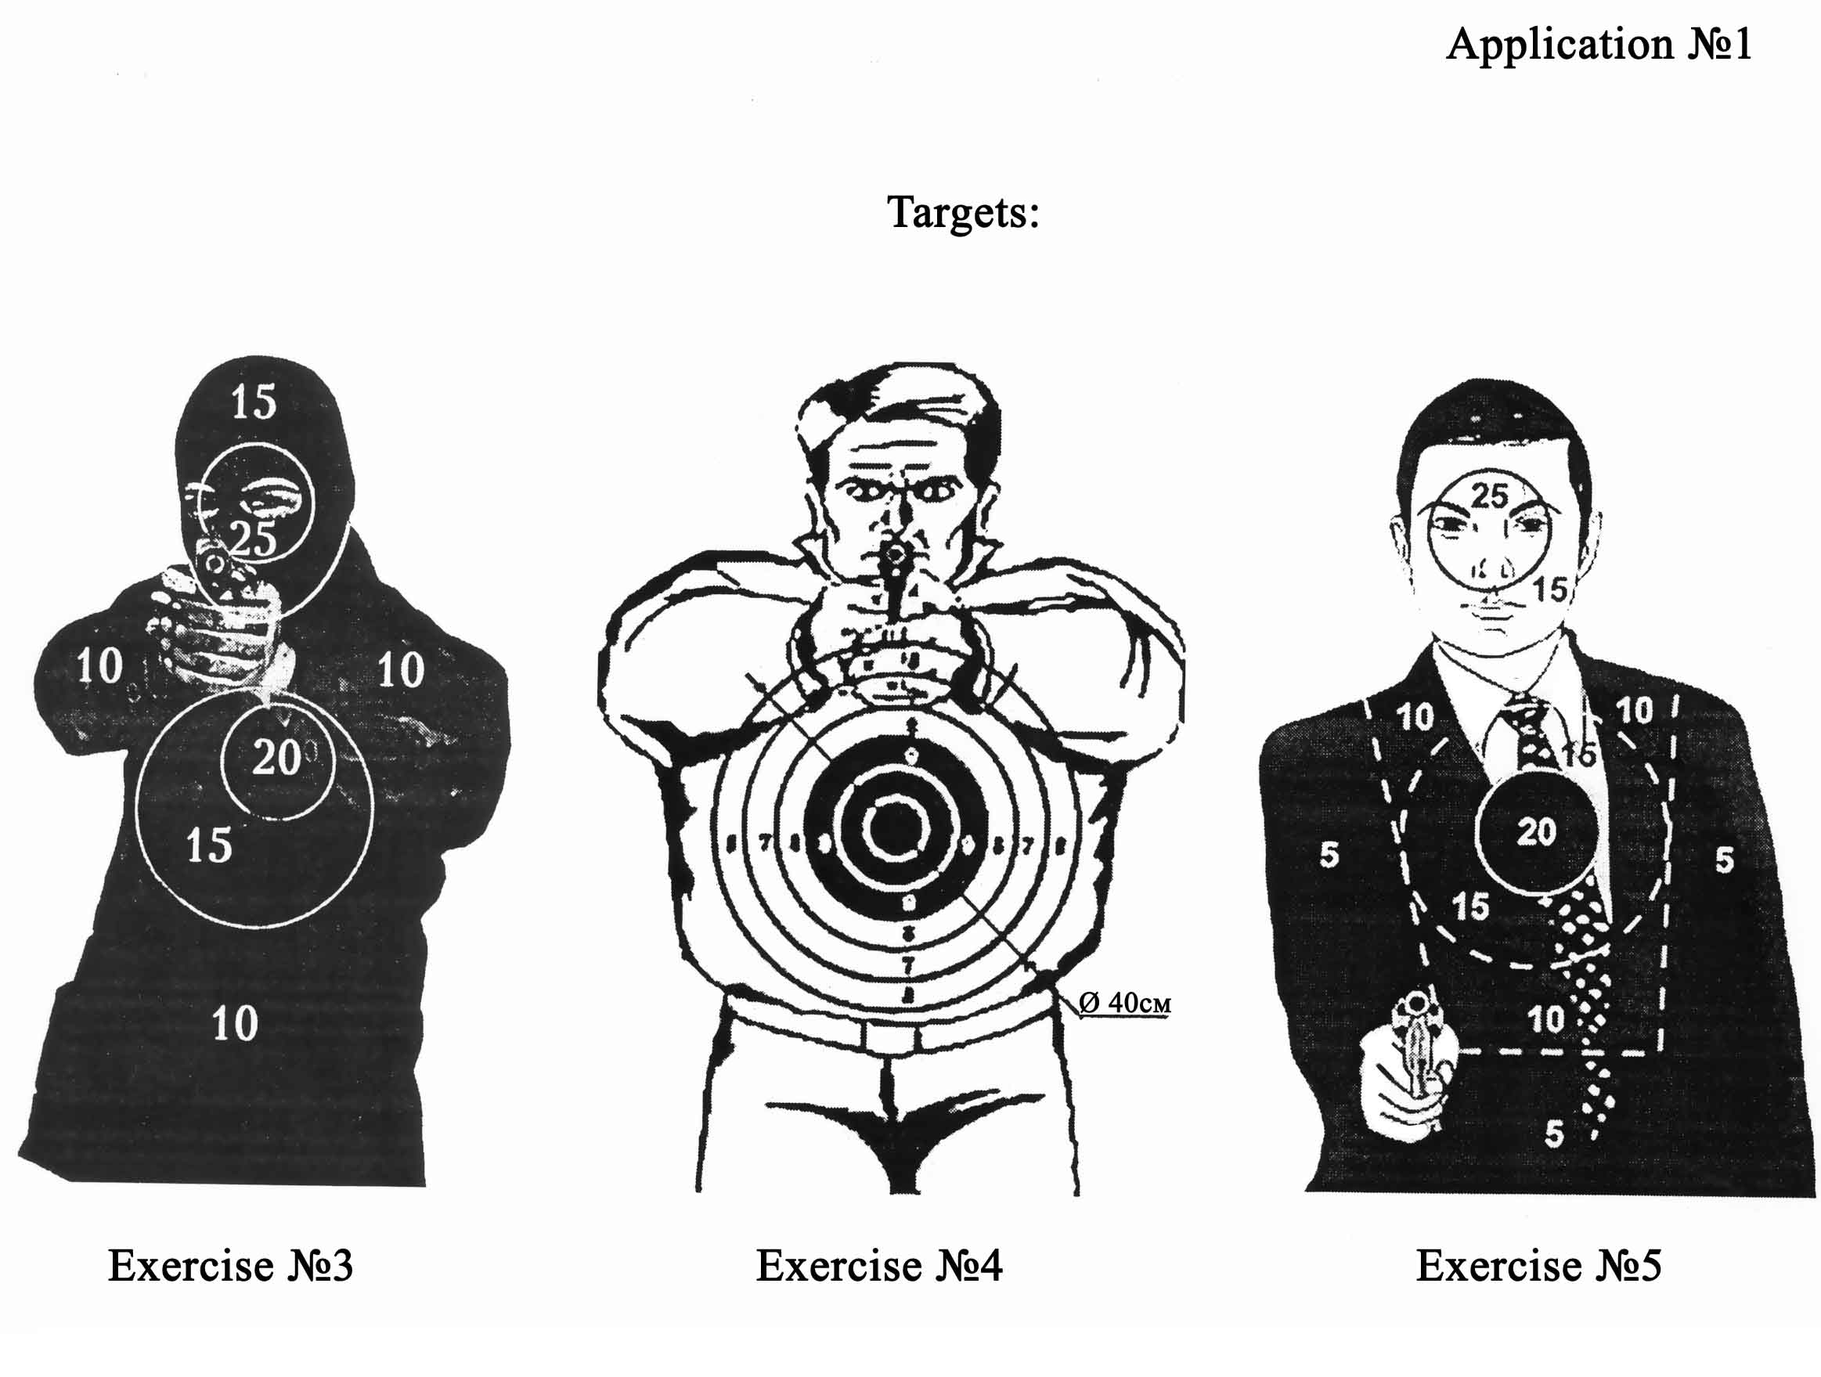

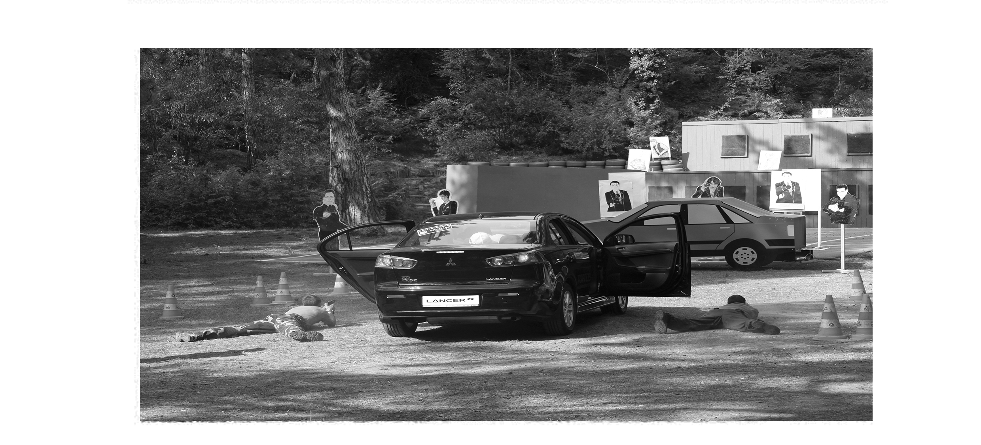
Shooting from a car
